ADRIAN TURION |  | Avenue de Sainte-Clotilde 9  1205 Geneva, Switzerland | 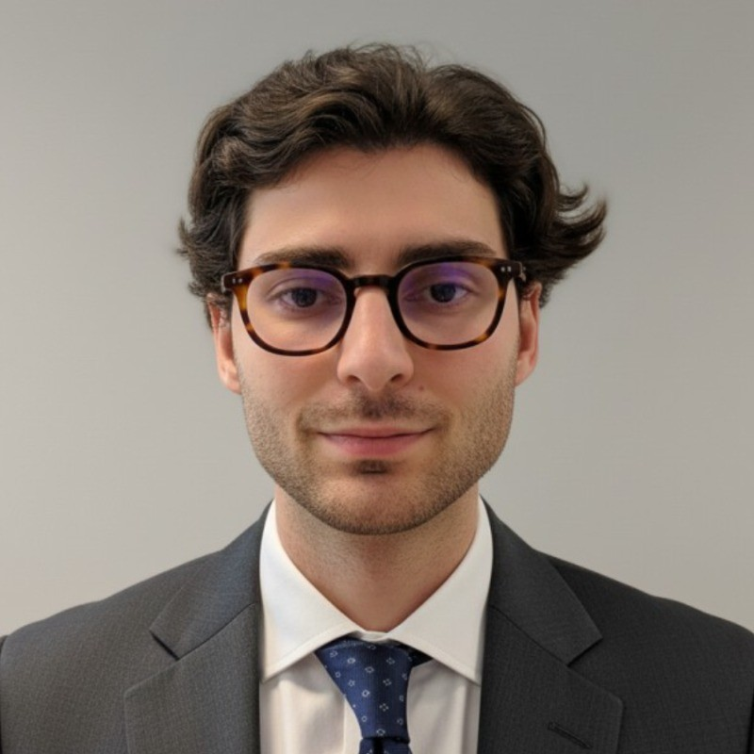
turionadrian@gmail.com | Swiss | 10.11.2000 |  | +41 77 262 37 96
INTRODUCTION
Finance professional with 3+ years in M&A analysis, FP&A, and management reporting. Built automated dashboards in Excel and PowerBI at Europ Assistance (CHF 50M+ revenue). Currently building financial models at Auraïa Capital across multiple mandates. Eager to support Rolex's Finance division in ERP evolution and BI tool development.
WORK EXPERIENCE
Auraïa Capital Advisory – Small & Mid Cap Cross-border M&A Boutique  Mergers & Acquisitions Analyst (Converted internship into full-time position) |  | Geneva, Switzerland  Aug 2024 – Current
- Built financial models (LBO, DCF, comps, precedent transactions) and prepared client presentations for Board meetings across 7 live mandates in healthcare, tech, and life sciences
- Coordinated with legal, tax, and accounting advisors to structure transactions and negotiate terms, managing client and counterparty relationships throughout deal lifecycle
- Led production of marketing materials and data room management across multiple concurrent mandates in a lean 3-person team, ensuring seamless information flow for cross-border transactions

RC Group – Currently under LBO with Crédit Mutuel Equity  Mergers & Acquisitions Intern |  | Paris, France  Feb 2024 – Aug 2024
- Prepared investment memos with market analysis, competitive positioning, and financial projections for 3 acquisitions, conducting due diligence on EUR 10M–30M targets in French healthcare and retail

Europ Assistance – Subsidiary of Generali Insurance  Financial Analyst Intern |  | Geneva, Switzerland  Apr 2023 – Aug 2023
- Supported CFO on FP&A for a CHF 50M+ revenue subsidiary, building automated dashboards in Excel and PowerBI to track KPIs, performing variance analysis on monthly P&L, and developing a cost allocation model

LEADERSHIP
- Finalist in 2024 McKinsey Business Case, presenting a data-driven model to forecast black swan events using order book data and statistical arbitrage with potential CHF 200K annual revenue gain
- Founded Screeny.ai, an AI-driven software for investment banks to identify acquirers, adopted by 3 advisory firms and reducing buyer search time from 10h+ to 20 minutes
- Led post-COVID financial recovery at AIESEC by sourcing corporate leads and negotiating partnerships, closing 3 key deals generating CHF 60K annual revenue and increasing volunteer placements by 40%
EDUCATION
HEC Lausanne  Master of Science in Finance |  | Lausanne, Switzerland  2021 – 2024
- Cumulative GPA: 5.2/6.0 (Top 15% of the class cohort)
- Exchange programs at Waseda University (Tokyo, Japan) and Maastricht University (Maastricht, Netherlands)
- Relevant Coursework: Corporate Finance, Data Science for Finance, Valuation, Financial Accounting
- Thesis Topic: Synergies Analysis of the Merger between American Airlines & US Airways

Bachelor of Science in Management |  | 2018 – 2021
- Cumulative GPA: 4.7/6.0

Scientific Baccalaureate with Highest Honors (16.6/20) |  | Aix-en-Provence, France
ADDITIONAL INFORMATION
Languages:  Computer:  Interests:  References: | French (Native, C2), Spanish (Native, C2), English (Fluent, C1), German (Business proficient, B2-C1)  Excel (VBA, Power Query) | PowerBI & Tableau | SAP | Financial Modeling  Geopolitics, Badminton (Provence regional finalist), Gym, Real use cases of Artificial Intelligence  Guillaume Arnaldez – Ex-Director at Auraïa Capital Advisory, guillaume.arnaldez@auraia.ch  Sacha Caravatti – CFO at Europ Assistance Switzerland, scaravatti@europ-assistance.ch

